
NATIONAL INSTITUTE OF TECHNOLOGY PUDUCHERRY
(An Institution of National Importance under MHRD, Govt. of India)
KARAIKAL – 609 609

DEPARTMENT OF COMPUTER SCIENCE AND ENGINEERING
Roll Number: | CS19B1016 | Name | BOYINA AJAY SANTHOSH
Semester: | II | Class: | B TECH 1ST YEAR
Subject Code: | CS106 | Subject Name: | DATA STRUCTURES LABORATORY

3. TOWER OF HANOI
Date:21.1.20

AIM:

To IMPLEMENT TOWER OF HANOI PROGRAM BY USING C PROGRAM.

ALGORITHM:

1. start the program.
2 . declare the variables.
3. move the top disc from rod 1 to rod 2
4. move the below disc (present in rod1) from rod1 to rod 3
5.now move the top disc in rod2 from rod2 to rod3.
6. repeat this process through recursive functions until all discs are empty in rod1.
7.print the steps what we done to move the discs from rod1 to rod3.
8.also print the no. of ways take place in this process.
9. Close the program.

PROGRAM:

#include<stdio.h>
#include<conio.h>
int top=0;
int main()
{
int n,a,b,c;
scanf("%d",&n);
a=1;b=2;c=3;
printf("MOVING DISCS FROM : \n");
TOH(n,a,b,c);
printf("\n");
printf("no. of ways of exchanging discs is %d\n",top);
getch();
}
int TOH(int n,int a,int b,int c)
{
if(n>0)
{
TOH(n-1,a,c,b);
printf("rod %d - rod %d\t",a,c);
TOH(n-1,b,a,c);
top++;
}
}

OUTPUT:

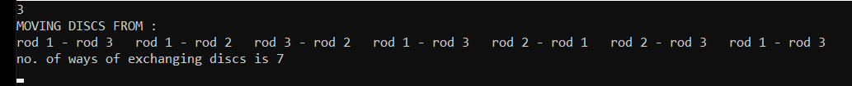

RESULT:

The program is successfully executed.

